For the given JSON iterate over all for loops (for, for in, for of, forEach)

1. **Using For Loop:**

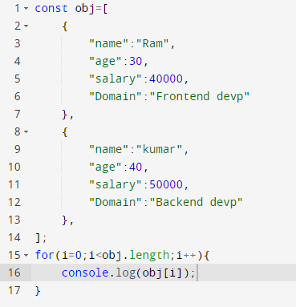

**Output:**



1. **Using For in Loop:**

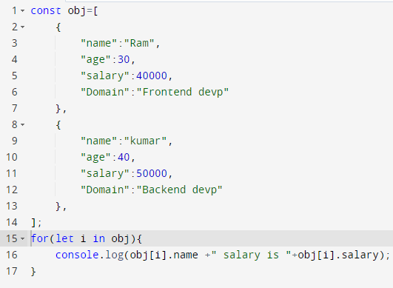

**Output:**



1. **Using For of Loop:**

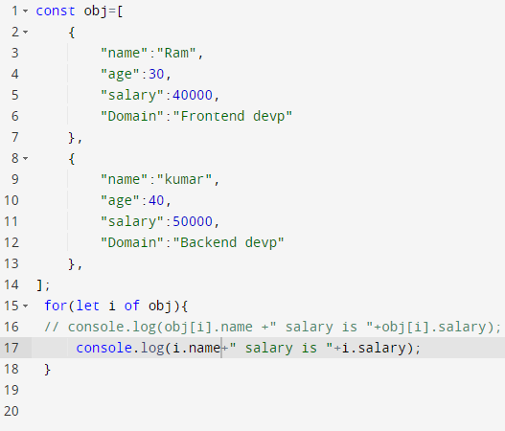

**Output:**



1. **Using For Each Loop:**

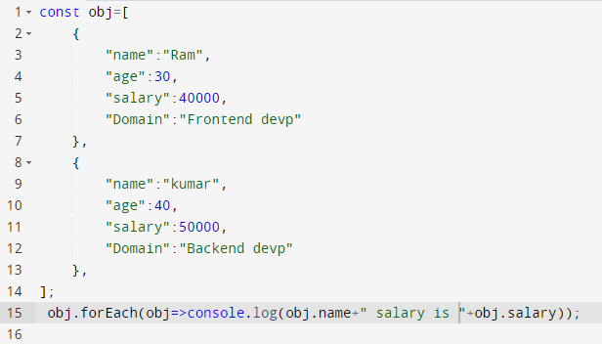

**Output:**

